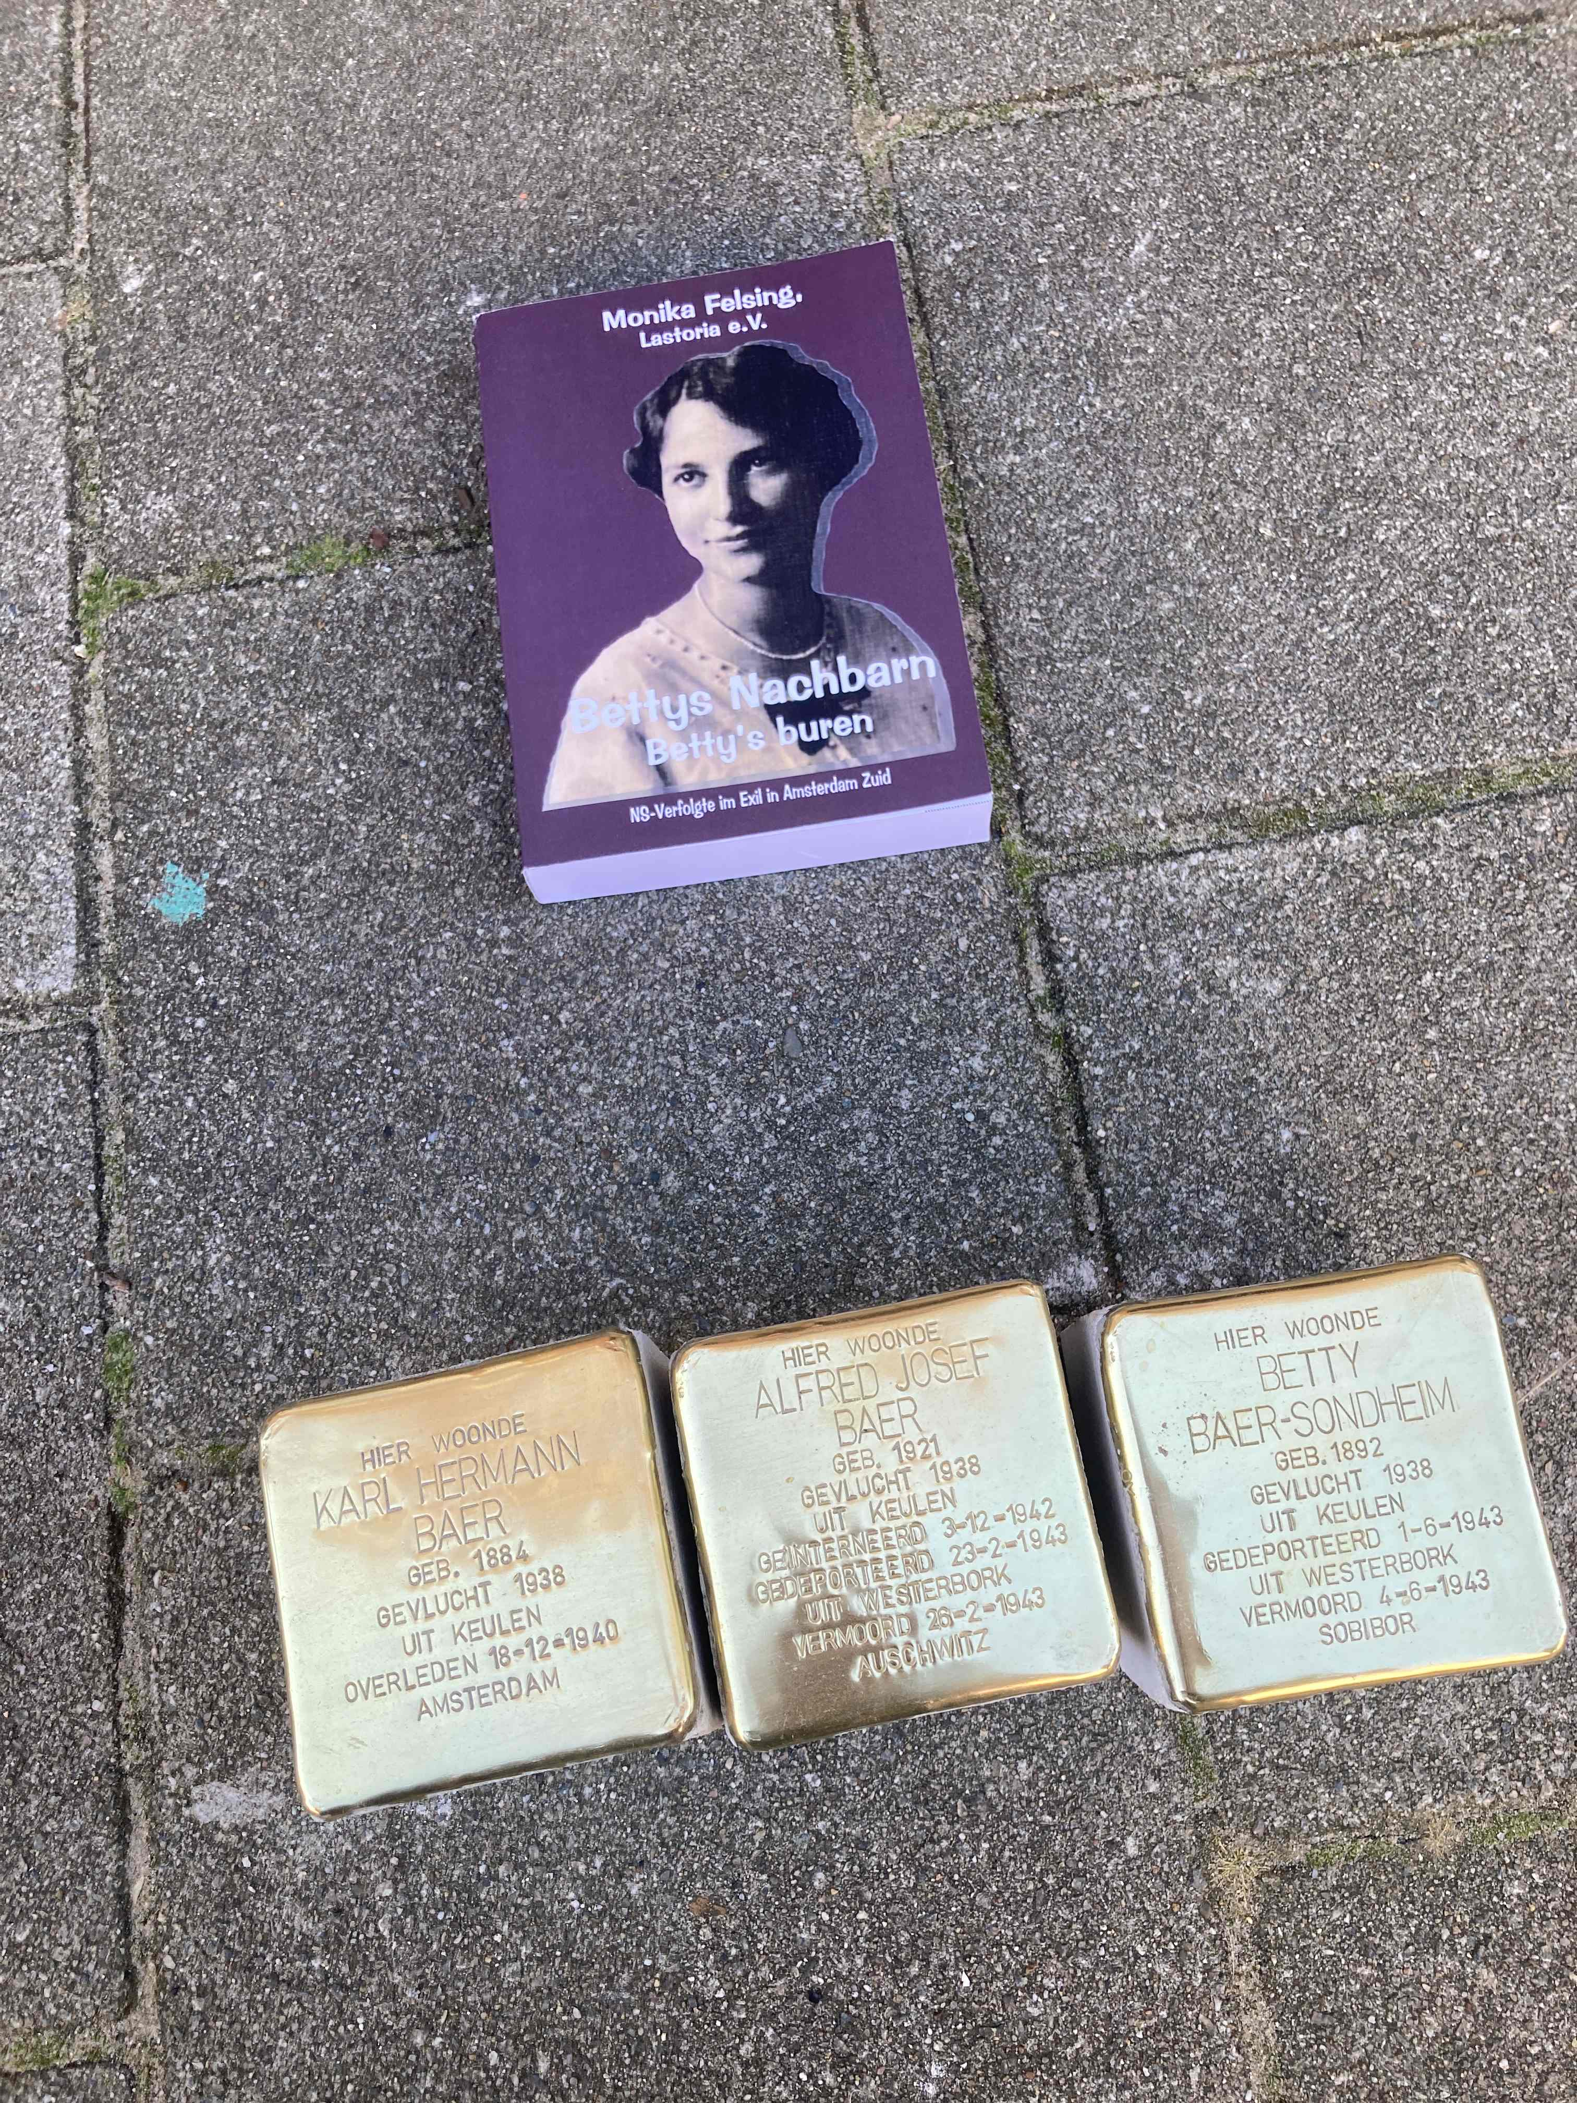**Betty, Karl und Alfred**

Monika Felsing

Photos: Justus Randt (Biesboschstraat)

and Monika Felsing

(for the other photos, please have a look

at the German version)

**Amsterdam.** They have come to stay for good. Betty Baer nee Sondheim, her husband Karl and her elder son Alfred are back in Biesboschstraat since September 2025. Not in their flat on second (for Americans: third) floor of number 31, from where at first Alfred and soon afterwards Betty had been deported to camp Westerbork, but right infront of it, some steps away from the open staircase. Their names, stamped in brass, can be read on the sidewalk. The three stumbling stones (Stolpersteine) are now part of allday life in this street as the fates of these three human beings are part of the history of Amsterdam Zuid.

**Betty Baer nee Sondheim**, born in 1892, has been murdered on the 4th of June in 1943 in Sobibor.

**Karl Hermann Baer** from Frankfurt upon Main, born in 1884, has died in Amsterdam on the first of December 1940.

**Alfred Baer**, born in 1921 in Cologne, has been murdered in Auschwitz on the 26th of February in Auschwitz.

Like so many other German refugees of the Nazi era, the Baers had hoped to emigrate to the U.S. and had fled to a safe neighbour country first. At the consulate of the U.S. in Rotterdam, they had applied for a permit. But in May 1940, just before Pentecoste, the German Wehrmacht invaded the neutral Netherlands. German aircraft bombed Rotterdam and other cities. So, the escape route was blocked for many persecuted people. The Netherlands were no safe harbour any more, but a trap. In the winter of 1940, Karl Baer died of a heart attack. He had been born in Frankfurt as family Frank that lived at Merwedeplein, right around the corner, and had worked as a banker. His wife Betty was from Ober-Gleen, a little village in Upper Hesse. Their sons Alfred und Herbert had been born in Cologne. With a kindertransport, Herbert had escaped to England, but as soon as the war started, he was declared an „enemy alien“ and soon deported to Australia.

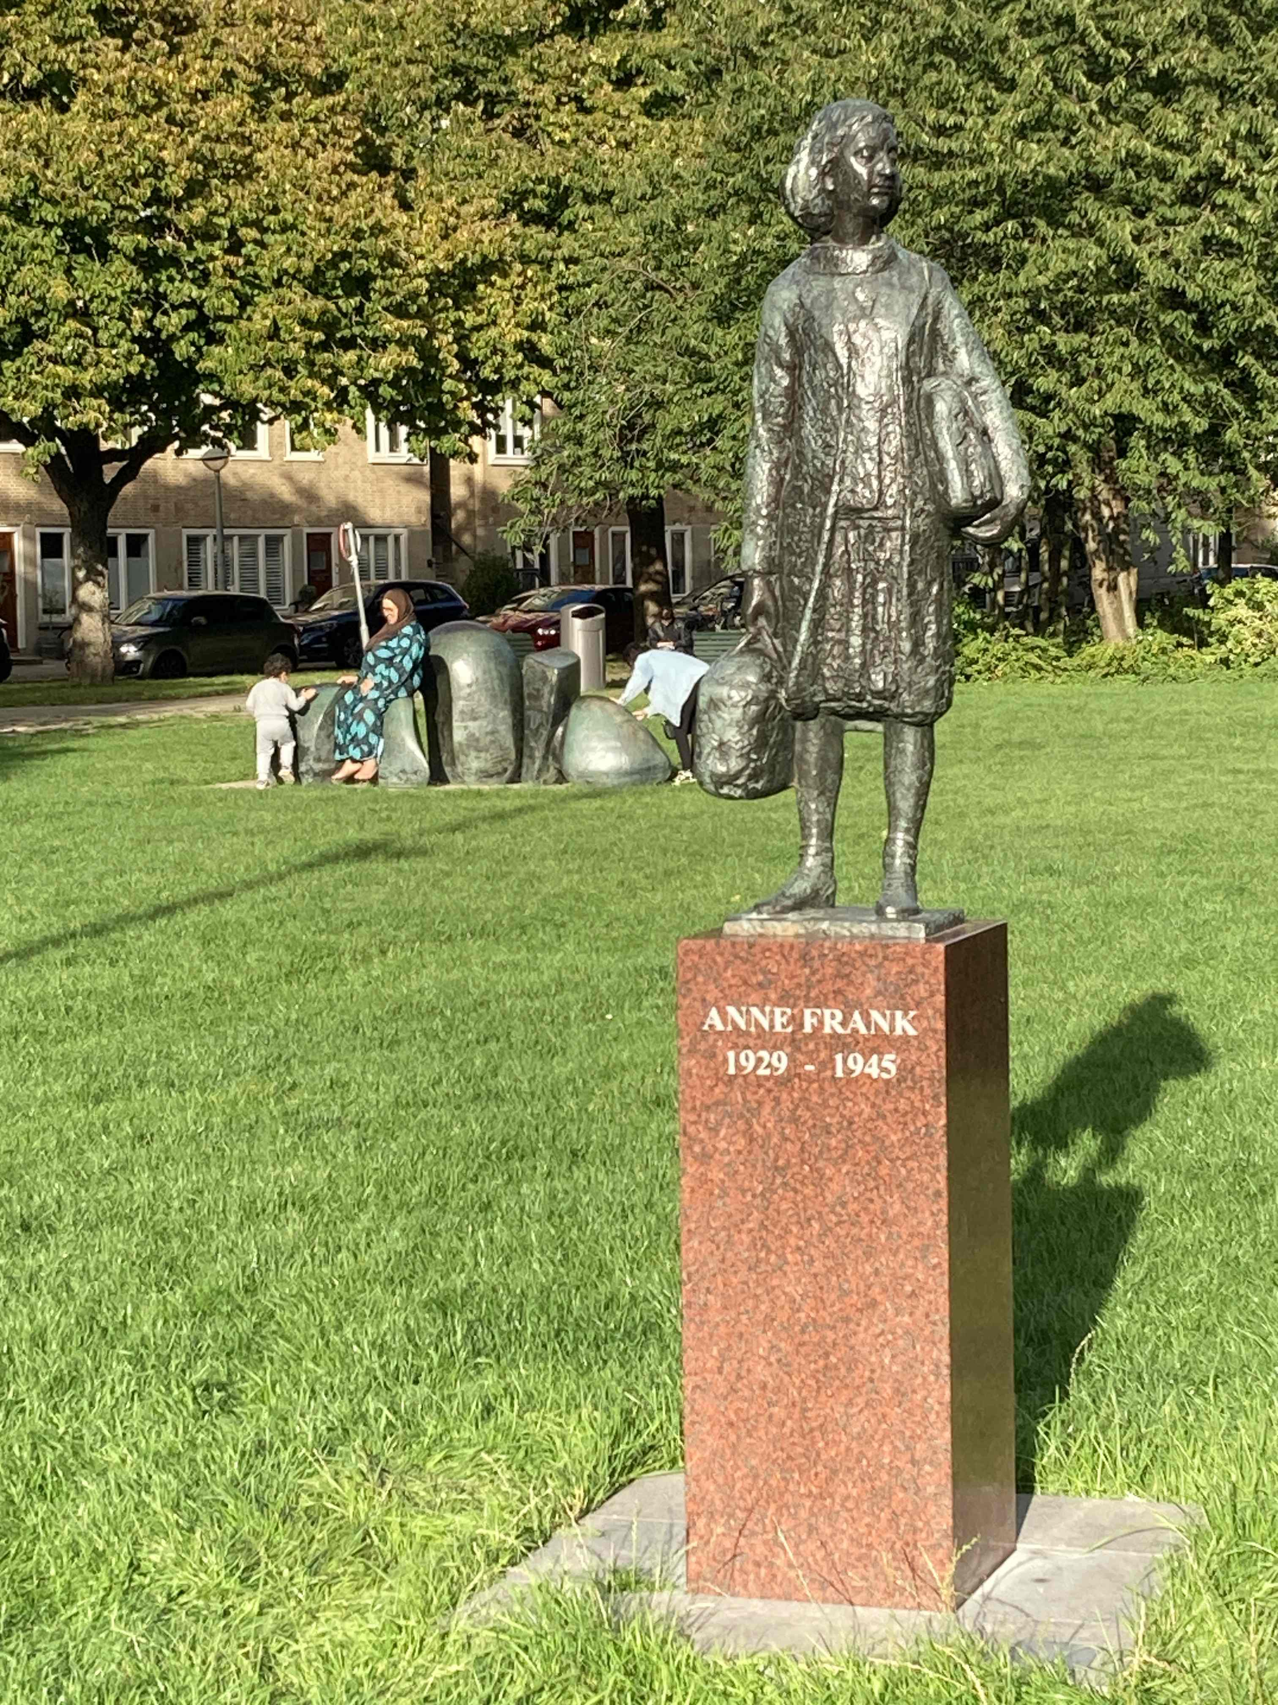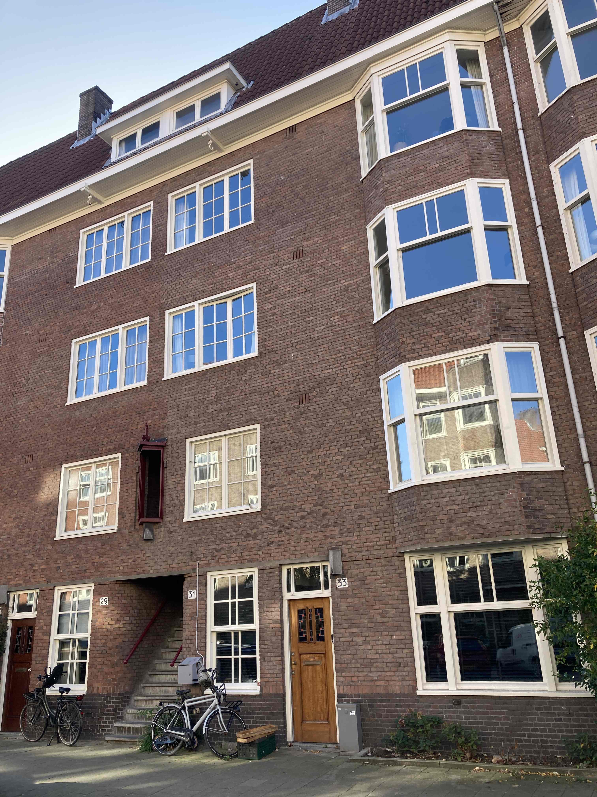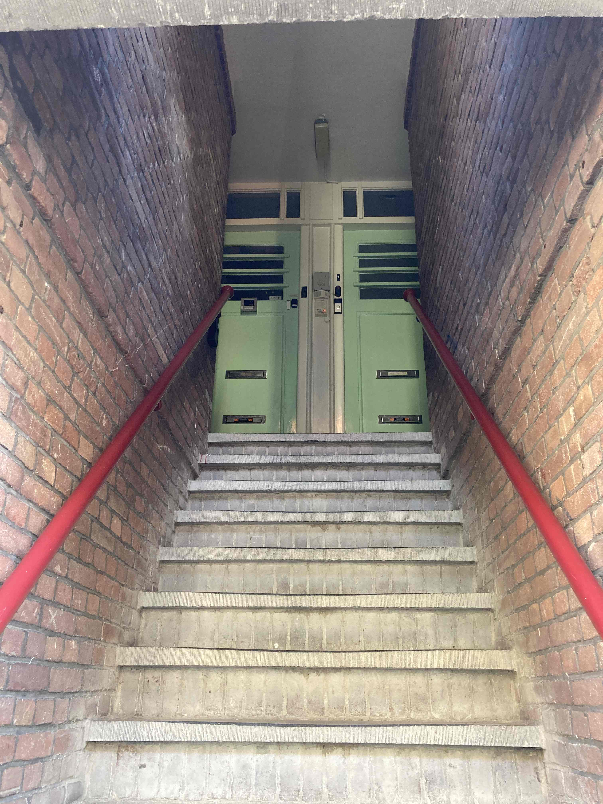

After Karl had died, Betty and Alfred desperately tried get overseas. Letters from this time show that some relatives cared. Betty’s brother Hermann and his wife Grete who meanwhile lived in Frankfurt inquired about the state of affairs. Betty’s sister-in-law Jette wrote from New York. On the first of June in 1943, Betty walked down the stairs for the last time and probably along the street to a meeting point. From there, she was brought to camp Westerbork in the Eastern part of the Netherlands. That Alfred was dead already, she couldn’t possibly have known. Alfred had been arrested in December 1942. Two months later, his name was on a list in Westerbork for one of the transports to Auschwitz that had been usually guarded by policemen from Bremen. Right after arrival, Alfred had been murdered. Betty had been, along with everyone else in her transport, forced to enter a gas chamber. Herbert Baer was the only one of his family who survived, far away from home, in Australia.

Wilfred and René from the City of Amsterdam who take care of all the stumbling stones (in Dutch: *Struikelstenen)* in Amsterdam, have done their job: With a crowbar, they have pried a slab of the sidewalk to gain some space. Then they have put the stumbling stones carefully into the ground, have added a fitting slab, worked on the stones with a rubber mallet and added water from a watering can, until the sand and everything else superfluous had been washed away and the brass gleamed in the sunlight.

The two donors of the three Stolpersteine for family Baer had been watching them, together with An Huitzing, one of the volunteers of the Stolperstein Foundation. Nobody from the house or the neighbourhood had shown up, no window was open. But still, there was a little ceremony, as „a human being is only forgotten if his or her name is“. The proverb from the Talmud has become the motto of the memorial project that the artist Gunter Demnig had started in 1992 and that now connects people in many countries and from several generations.

Some words have been said in the memory of Betty, Karl and Alfred on that Thursday morning in September in Biesboschstraat, words about their life and death, and a memorial song had been sung to the melody of a song that had once been sung in Hessian Synagogues before circumcision: The new lyrics consist of dozens of first and second names of Jews from Ober-Gleen, strung together like pearls on a necklace that never has been torn apart. Betty’s name is among them. And on the cover of a book, she smiles into the camera. It is one of the photos that remained to the family.

Betty’s Stolperstein is one of 2000 that An Huitzing from the Stolperstein Foundation has helped to put into the ground in recent years. The anthropologist is living in Amsterdam and volunteers in memorial work. In 2017, together with her daughter Tamara Becker, she has published the book „Op de foto in oorlogstijd, Studio Wolff 1943“. It containts portraits of more than 300 people, photos taken by the Bavarian photographer Annemie Wolff in her flat in Amsterdam Zuid in 1943. An exhibition in the Nationaal Holocaust Museum followed and in 2021 another book: „Spartelend aan de fuik ontkomen. Hoe tientallen leden van een Joodse familie de oorlog overleefden“.

Few have survived, either in hiding or because they had managed to leave the country just in time. Since 2015, the historical society Lastoria, Bremen, does research in the project „Deutschland auf der Flucht“ (Germany on the Run) and tries to find out what has become of those who, like family Frank from Frankfurt, had fled their home countries to escape the Nazis: children like Gabriele Silten **(„Between Two World“, „Is the War Over“ / „Zwischen zwei Welten“, „Ist der Krieg vorbei?“)** from Berlin and Hans Cossen from East Frisia, people like Hermann Deutschland from Bremen or family Baer from Frankfurt, Cologne and Ober-Gleen.

On the workbench in the Stolperstein workshop in the garden of the Goethe Institute in Amsterdam, letter by letter, number by number, is hammered into metal plates. Almost like in a typesetting shop, the letters and numbers are waiting on a shelf, material for the names, dates of birth, places of residence, dates and places of deportation and murder. Everything has to be perfect, the text exactly according to the template, the spacing in the smallest of spaces. It’s precision work with a hammer. Once the plate is finished, it is placed face down in a wooden mold that will be filled with concrete. Once the concrete has hardened, a Stolperstein is ready, telling a story of life and of suffering in just a few words. Another piece of a puzzle, another contribution to one of the largest memorial projects in the world.

In Elbenrod in the Vogelsberg district, not far from Betty’s homevillage, Gunter Demnig lives and works for several years now. In addition to his own atelier and the one in Berlin, there is one in Amsterdam for the production of Stolpersteine since 2021. The stones made in Amsterdam are for the Netherlands, for Luxemburg and Belgium. At the Stichting Stolpersteine, one can apply for stumbling stones, and who asks for them, pays for them. One Stolperstein is 150 Euro today. Who wonders how these handcrafted stones are made, can register online for a guided toor at the Goethe-Institut, Herengracht 470. Or have a look through the window.

After the stones for Betty, Karl and Alfred had been put into the ground, An Huitzing had read the inscriptions aloud that had been engraved in the small brass plates: „Hier woonde…“

Biesboschstraat 31 II is not the only place in Amsterdam, where Betty and her family are remembered. In the Nationaal Holocaust Namenmonument in Weesperstraat close to the former Jewish quarter, the names and life dates of about 102.000 Jews and 220 Sinti and Roma who had been deported and murdered during the occupation (1940-1945), are to be read on brickstones. Also the ones of Betty and Alfred.

With our memorial book „Bettys Nachbarn. Betty’s buren“ (Betty’s neighbours), our historical society Lastoria, Bremen, remembers German speaking persecuted people from the Nazi era, people from different countries who had been registered in Amsterdam Zuid. In this book, you find very short biographies of hundreds of mostly Jewish women, men and children from different German federal states and other regions, informations that I have found in books and online, on page as those of Monument, Dokin (children and teenagers from Germany and Austria who had been without their families in the Netherlands), of Alemannia Judaica, of cities and towns, of genealogy projects and Stolperstein groups. People in exile who had hoped to survive. In the river quarter in Amsterdam, some of them will have run into each other in the streets. Also in Biesboschstraat where Alfred, Betty and Karl had been safe for a short while.

**Contact**

**and further informations:**

**www.monikafelsing.de**

**Where family Sondheim is also remembered:**

**On plates with engraved names on the fieldstone wall of the cemetery of Ober-Gleen**

**On a Jewish cemetery in Amsterdam or the area: Karl’s grave.**

**There are Stolpersteine for Hermann, Fanny Grete Sondheim nee Altstädter and their son Kurt in Melemstraße 6, Frankfurt/Main**. Hermann and Grete were deported and died in Lodz in 1941. Kurt survived in England and has changed his name. The stones have been donated by Marlies Rahe from Ober-Gleen.

**In the oral-history-project of Lastoria in Ober-Gleen -** especially, but not only, in the book **„Himmel un Höll“** and in the **audiobook „Jiddisch Leben“** about Jewish Life in Upper Hesse and exile. When doing research, we have found documents: a booklet in which Betty’s niece Addi had written the names, birth dates and so on of her ancestors, two invoices from Sondheim’s store from 1911 and 1933 and two letters written by Heinz Sondheim from Cologne to family Gemmer in Ober-Gleen in 1945 and 1946.

**In the coversongs „Betty, Ruth on Elsa“** (to the Melody of „Go down, Moses“) **and „Herz“** (to the melody of a Synagogical song) with names of Jewish people from Ober-Gleen, both lyrics written by Monika Felsing.

**In fairy tales** in Upper Hessian dialect that we publish as audios in my blog and in books in dialect and German.

**In the podcast „Now we go… Overseas“,** Herbert Sondheim from Ober-Gleen, a nephew of Betty and Karl, is to be heard as well as his daughter Robin Smolen nee Sondheim and a piece of Beethoven, wonderfully played by Herbert’s grandson Henry Smolen, a phantastic musician. This podcast is to be found in the blog on [www.monikafelsing.de](http://www.monikafelsing.de/)

**Please contact us if you want to know more about it or if you have informations for us.**

All the best! Monika Felsing and Justus Randt, historical society Lastoria, Bremen